Table of contents
NOTES ON James Brah’s 2
The technique that author used that did not work for him are 2
SYMBOLS & glyph 3
The Planets glyph 3
The Zodiac glyph 3
PLANETARY SYMBOLS 4
SIGN SYMBOLS 4
PLANETARY DIRECTIONS 4
BODY RULERSHIPS 5
South and North Indian Chart 5
My zodiac charts 6
Important 7
The Planets 8
☉ THE SUN Atmakaraka 8
INDICATIONS OF THE SUN 8
☾ MOON The Most Important 8
INDICATIONS OF THE MOON 10
Tithi Reference 11
Shukla Paksha & Tithi (Waxing Phase — Gaining Light) 11
Krishna Paksha & Tithi (Waning Phase — Losing Light) 12
♂ MARS 13
Notes on mars 13
INDICATIONS OF MARS 13
59 14

NOTES ON James Brah’s

Ancient Hindu Astrology For the Modern Western Astrologer Revised and Expanded 2020 Edition (James Braha)

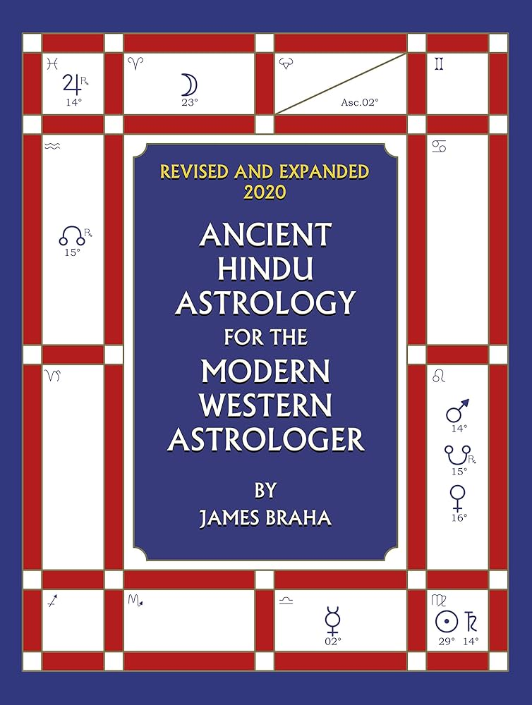

The technique that author used that did not work for him are
- Vargottama
- Neechabhanga Rajayoga

SYMBOLS & glyph

The Planets glyph
Sun | ☉
Moon | ☾
Mercury | ☿
Venus | ♀
Mars | ♂
Jupiter | ♃
Saturn | ♄
Rahu | ☊
Ketu | ☋

The Zodiac glyph
Aries | ♈︎
Taurus | ♉︎
Gemini | ♊︎
Cancer | ♋︎
Leo | ♌︎
Virgo | ♍︎
Libra | ♎︎
Scorpio | ♏︎
Sagittarius | ♐︎
Capricorn | ♑︎
Aquarius | ♒︎
Pisces | ♓︎

PLANETARY SYMBOLS
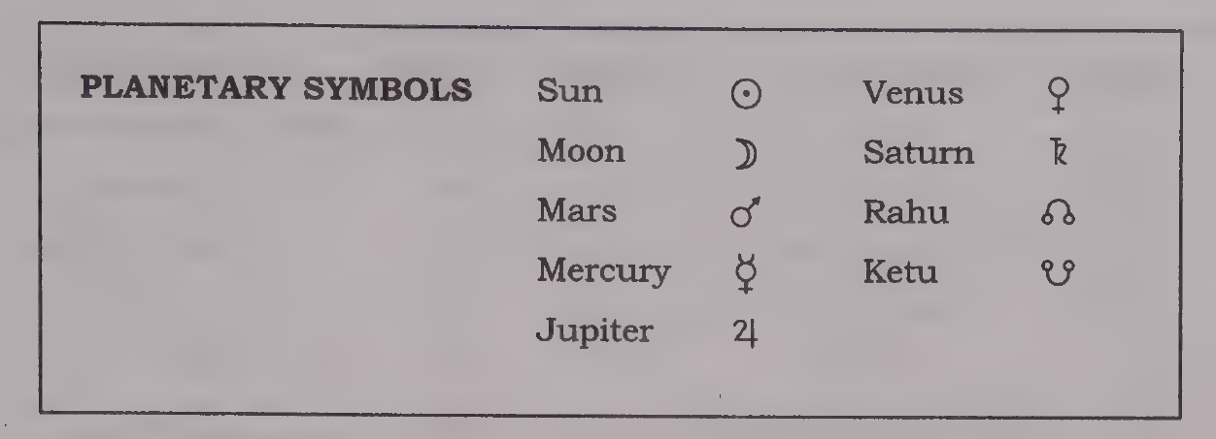

SIGN SYMBOLS
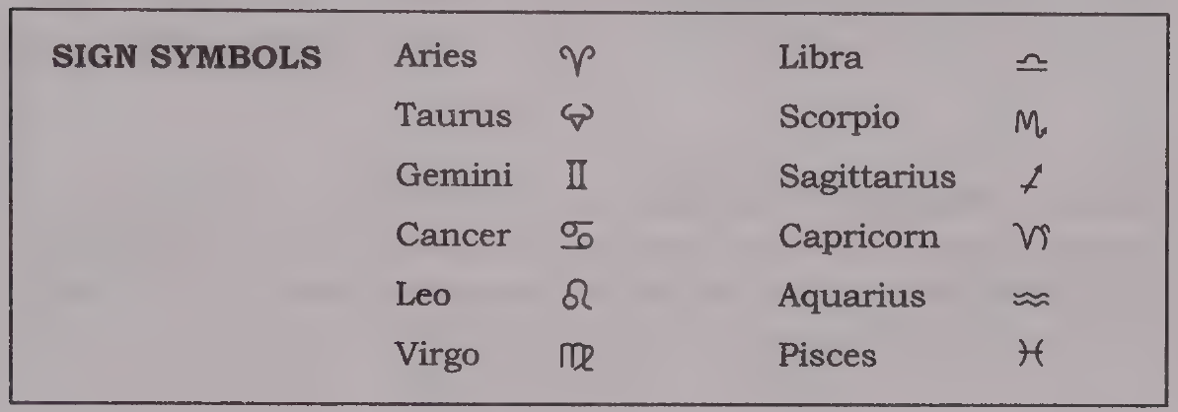

PLANETARY DIRECTIONS
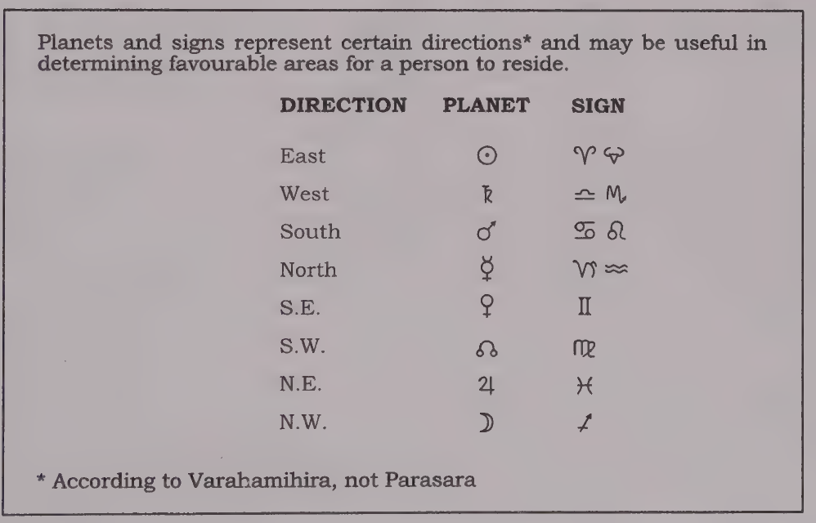

BODY RULERSHIPS
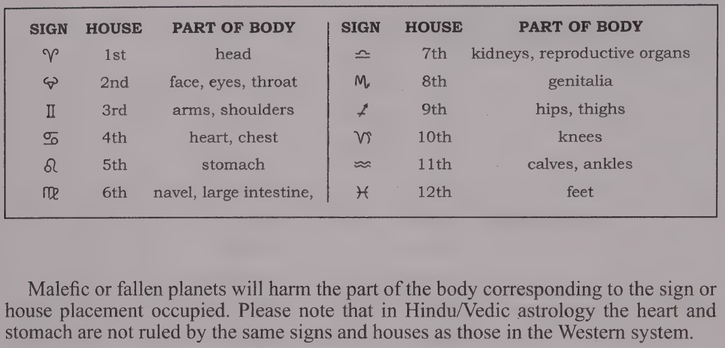

South and North Indian Chart
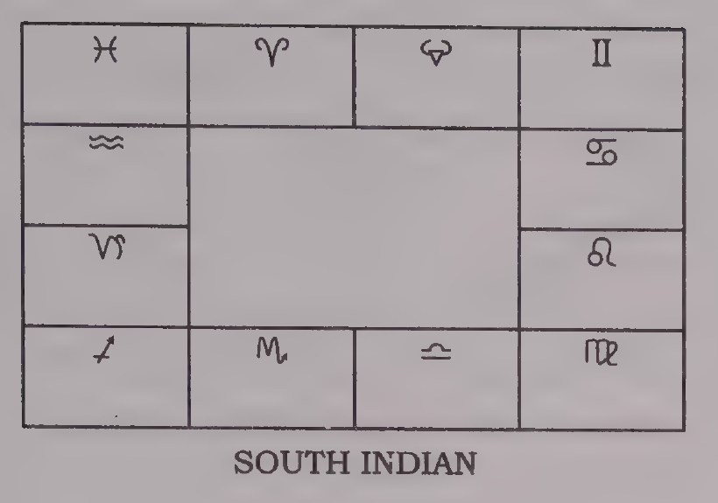  South | 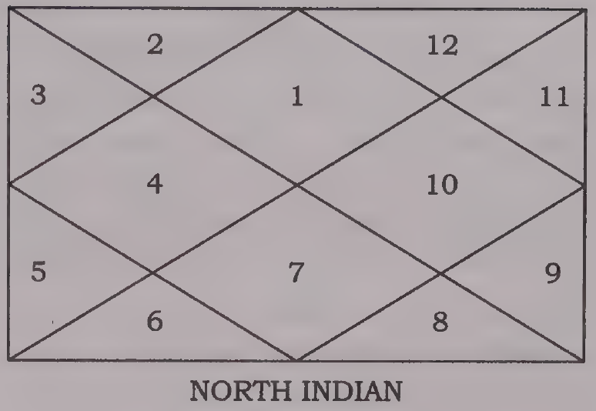  North

My zodiac charts
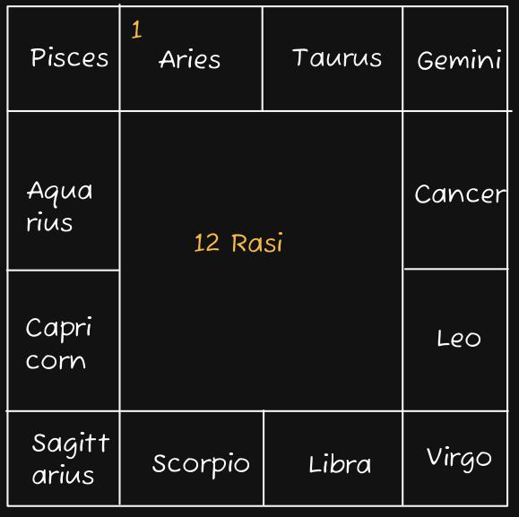 | 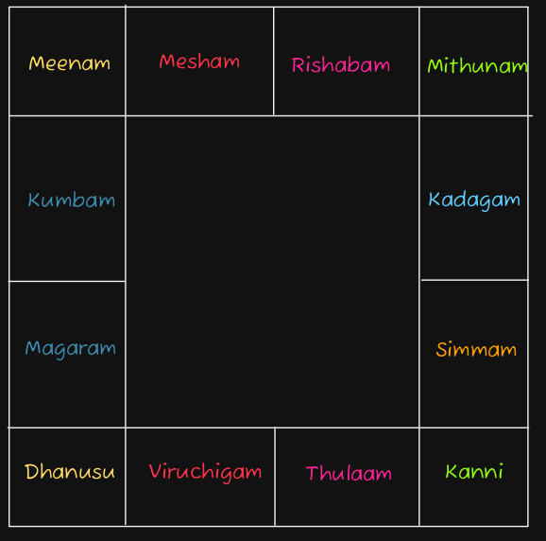
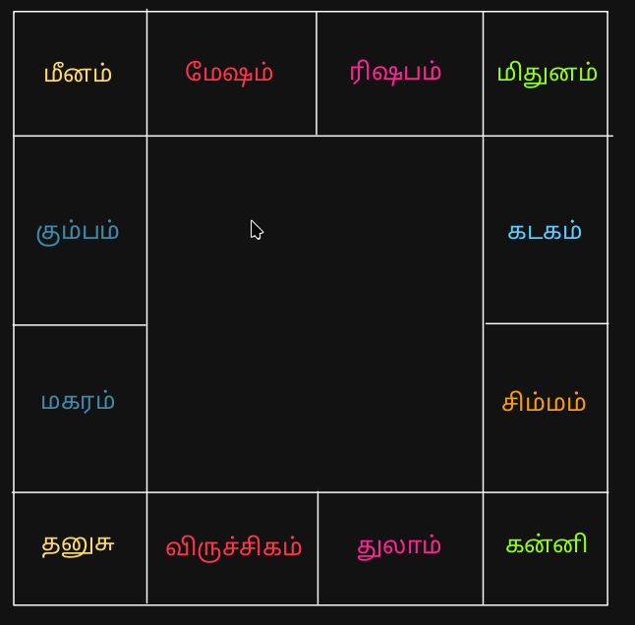 | 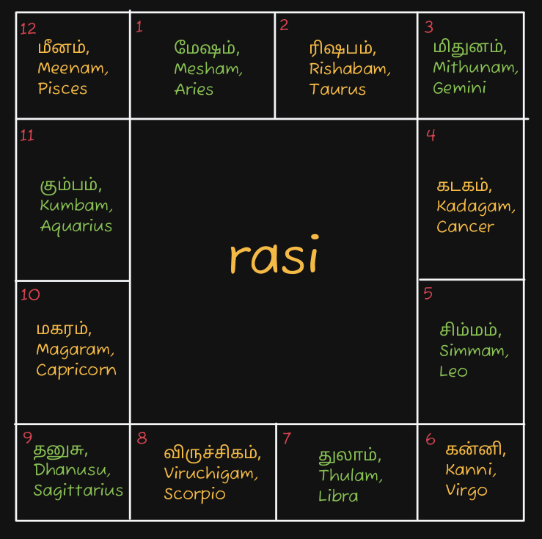

Important
Always bear in mind that the foundation of any horoscope belongs to the Sun, Moon,and ascendant. If they are all strong and well disposed, the person has great confidence and ability to function in the world. If these influences are weak and afflicted, worldly life is stressful and difficult.

The Planets

☉ THE SUN Atmakaraka
Page 51
planet that is posited within 8 degrees of the Sun is burnt This condition is called combust

INDICATIONS OF THE SUN
- father
- the soul, ego
- power, ambition
- vitality, dignity, self-reliance
- authority or rulership position
- government
- vocation
- professional status, position, popularity
- physicians, chemists, druggists
- the eyes, vision
- the heart
- copper, gold
- eastern direction
- Sunday
- red ruby
- the color gold

☾ MOON The Most Important
Page 53
Most Important next to ascendant
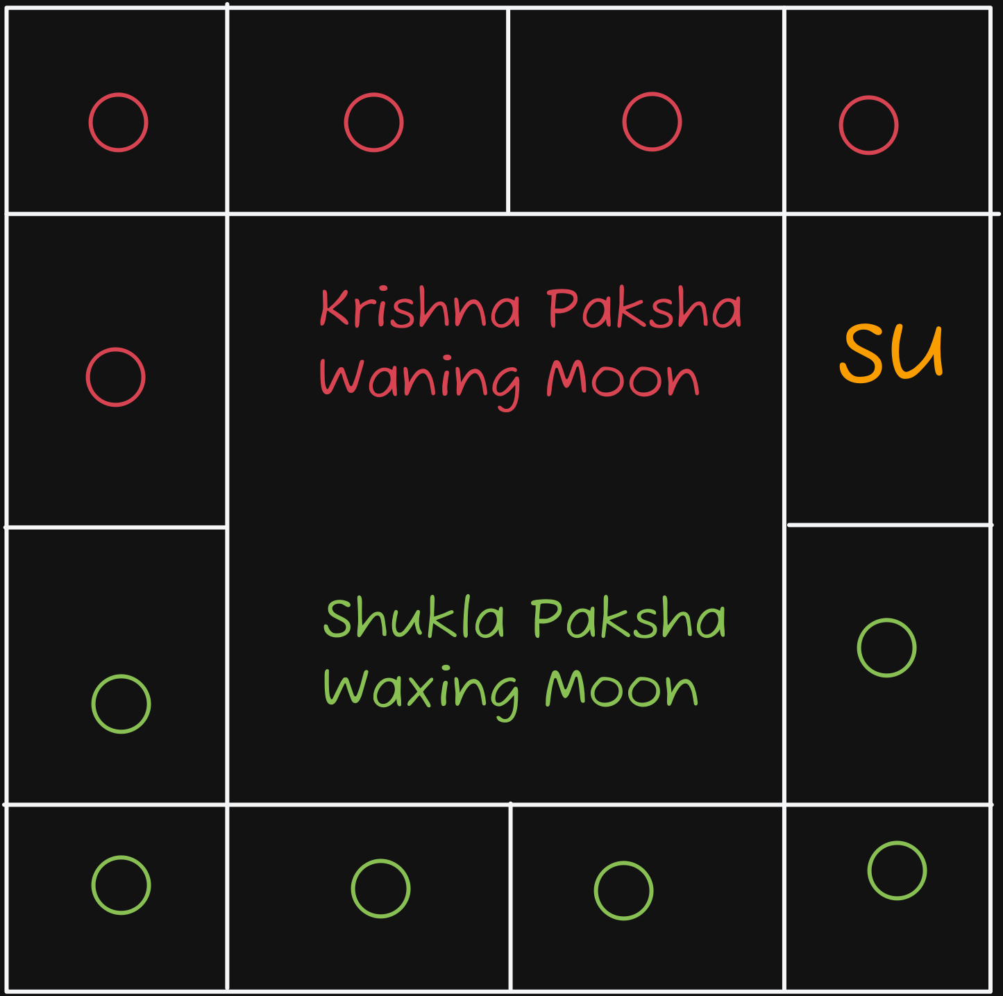
Waxing Moon (Shukla Paksha):
- The Moon is moving away from the Sun, heading towards the point directly opposite it (7 houses away / 180°).
- Vedic term: Shukla Paksha
Waning Moon (Krishna Paksha):
- The Moon has passed the opposite point (Full Moon) and is now moving back towards the Sun to meet it again.
- Vedic term: Krishna Paksha

INDICATIONS OF THE MOON
- mother
- females
- the mind, common sense, memory
- the public, mass consciousness
- emotions
- general well being (affluence, fortune, recognition and fame)
- fluctuations, moodiness, instability
- sensitivity, femininity
- milk, grains, liquids
- growth (health in childhood), fertility
- cooks, nurses, caterers I
- eyesight
- breasts, brain, stomach
- pearls
- the metal silver
- northwestern direction
- Monday
- menstrual cycle

Tithi Reference

Shukla Paksha & Tithi (Waxing Phase — Gaining Light)
Tithi | Name | Phase & Brightness Level
1 | Pratipada | ~0% – 7% (Just after New Moon)
2 | Dwitiya | ~7% – 13%
3 | Tritiya | ~13% – 20%
4 | Chaturthi | ~20% – 27%
5 | Panchami | ~27% – 33%
6 | Shasthi | ~33% – 40%
7 | Saptami | ~40% – 47%
8 | Ashtami | ~50% (First Quarter / Half Moon)
9 | Navami | ~53% – 60%
10 | Dashami | ~60% – 67%
11 | Ekadashi | ~67% – 73%
12 | Dwadashi | ~73% – 80%
13 | Trayodashi | ~80% – 87%
14 | Chaturdashi | ~87% – 93%
15 | Purnima | 100% (Full Moon — Peak Brightness)

Krishna Paksha & Tithi (Waning Phase — Losing Light)
Tithi | Name | Phase & Brightness Level
1 | Pratipada | ~93% – 100% (Just after Full Moon)
2 | Dwitiya | ~87% – 93%
3 | Tritiya | ~80% – 87%
4 | Chaturthi | ~73% – 80%
5 | Panchami | ~67% – 73%
6 | Shasthi | ~60% – 67%
7 | Saptami | ~53% – 60%
8 | Ashtami | ~50% (Third Quarter / Half Moon)
9 | Navami | ~40% – 47%
10 | Dashami | ~33% – 40%
11 | Ekadashi | ~27% – 33%
12 | Dwadashi | ~20% – 27%
13 | Trayodashi | ~13% – 20%
14 | Chaturdashi | ~7% – 13%
15 | Amavasya | 0% (New Moon — Complete Darkness)

♂ MARS
Page 57

Notes on mars
Mars is the indicator of brothers and sisters, except for the eldest. a malefic such as Mars causes troubles, disputes, and miseries unless it is posited in one of the upachaya, or growing, houses (the 3rd, 6th, 10th, or 11th), where malefics produce good effects. Even though malefics are good in these houses, malefics in the 3rd will hurt brothers and sisters, while malefics in the 11th may hurt the eldest sibling, friends, and groups. Mars is masculine, dry, and fiery. It is best placed in the 10th house, where it receives dik bala, or directional strength. It operates best in Capricorn, its exalted sign, and worst in Cancer, its fallen placement. It also functions well in Aries and Scorpio, the signs it rules. The friends who welcome Mars in their houses are the Sun, Moon, and Jupiter. Mercury is its enemy, while Venus and Saturn are neutral in friendship.

INDICATIONS OF MARS
- brothers and sisters (except the eldest, which is ruled by Jupiter)
- courage, bravery, heroic deeds
- sports
- property
- computer work, mechanical or technical ability
- builders, designers, engineers, surgeons, mechanics
- the military, soldiers, police, war
- generals, commanders, rulers
- accidents, violence, fires
- cuts, burns, bruises
- ambition, motivation, desires
- physical strength, forcefulness
- temper, arguments, fights
- weapons, guns, explosives
- energy, aggressiveness
- passions, sex
- medical operations
- the blood, muscular system, bone marrow, fevers
- Tuesday
- southern direction
- red coral

59

